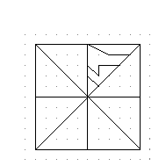Rangoli Patterns

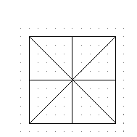Step 1: Construct this 10 × 10 grid. It is the basis for the pattern.

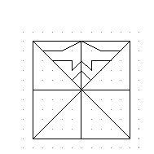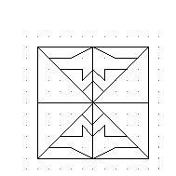 Step 2: Using the dots as a guide, draw any three lines in the top right section. Be imaginative and choose your own lines!

Step 3: Reflect your lines in the vertical line to complete the top section.

Step 4: Now reflect this complete pattern in the horizontal line. The bottom section of the grid should now be full too.

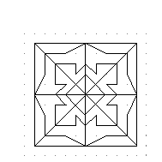

Step 5: Choose one of the diagonal lines. First reflect the top section in this line. Then reflect the bottom section in the same line. All the separate sections of the pattern should now join together neatly.

- How many lines of symmetry does your Rangoli Pattern have?
- Colour your pattern in bright colours. Be careful not to destroy any of the symmetry. The colours must be reflected too.
- Does it matter which of the diagonal lines you choose to reflect in, in Step 5? Explain your answer.
- Experiment with larger grids or more lines in Step 2.
- When families have designed a pattern for their home, they repeat it many times and join them together. This makes even more shapes. Try this as a group and see what you find.

